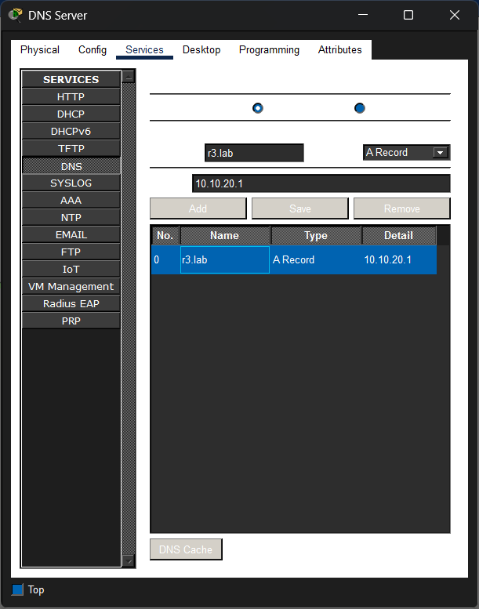
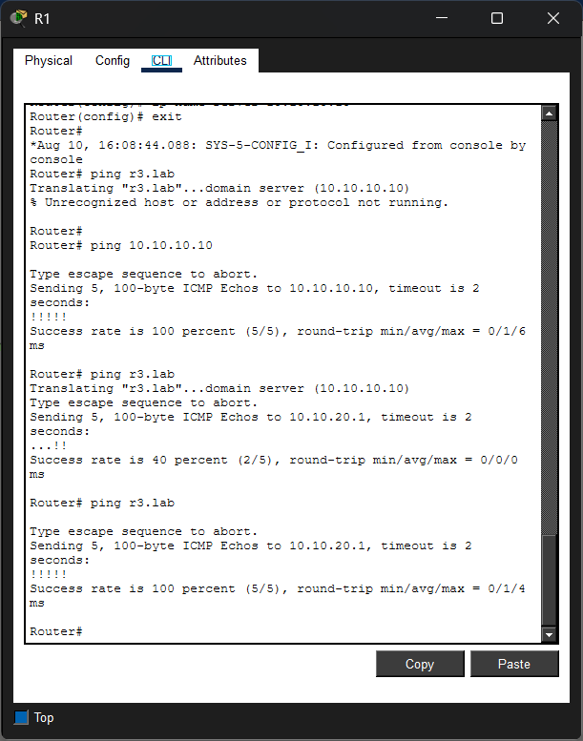
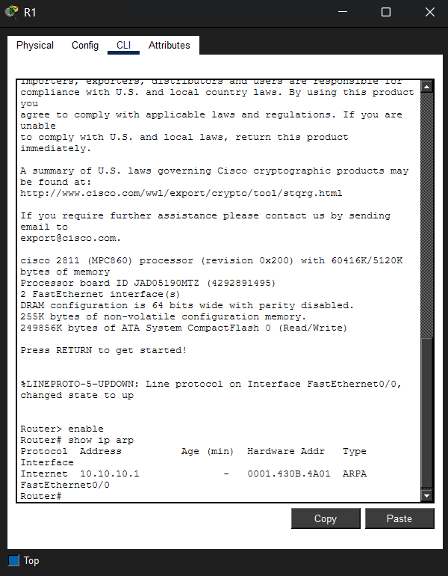

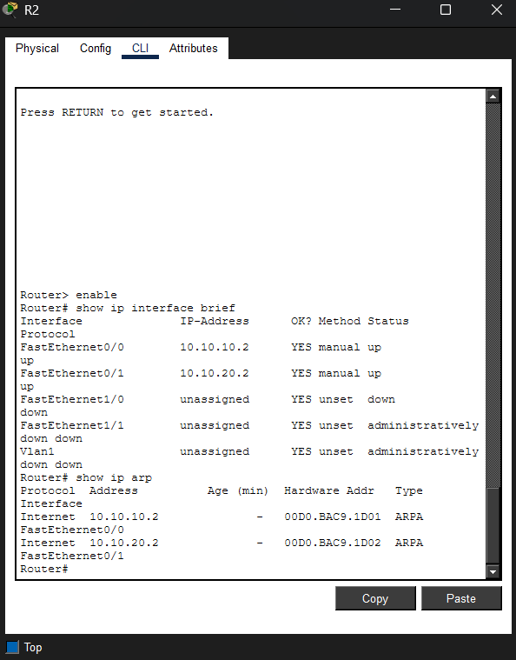
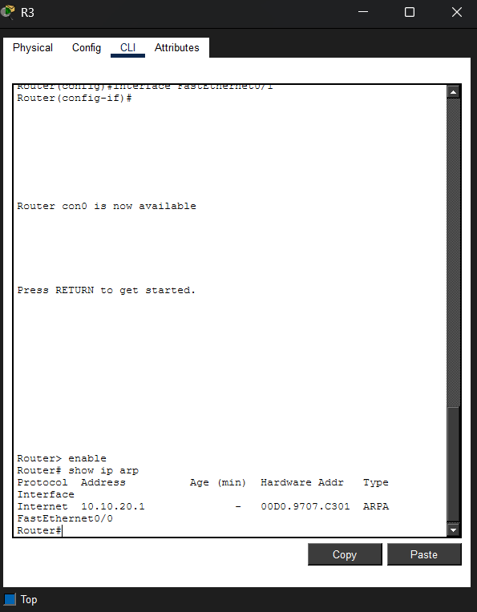
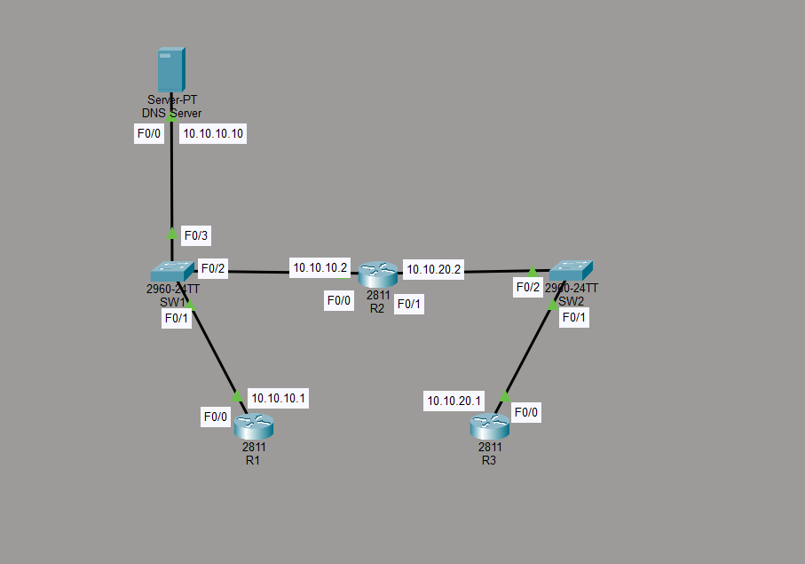
20. ARP requests only work within a single Layer 2 broadcast domain. Because R3 is on a different network (10.10.20.0/24), R1 must encapsulate the IP packet inside an Ethernet frame addressed to its local gateway, R2 (10.10.10.2). R2 then re-captures the packet to forward it to R3.
21. While R1 holds the ICMP packet in memory, it must first send an ARP broadcast to learn the destination MAC address for the next jump. The timeout occurs while waiting for the ARP reply to complete.

